Testing

Junit hook functions.

Test suite : it is use to run more than one test case file or class.

Spring boot testing

Login-app

Starter -🡪Web Starter

Starter -🡪JPA

Dependency 🡪 MySQL

Starter ->testing starter (by default added)

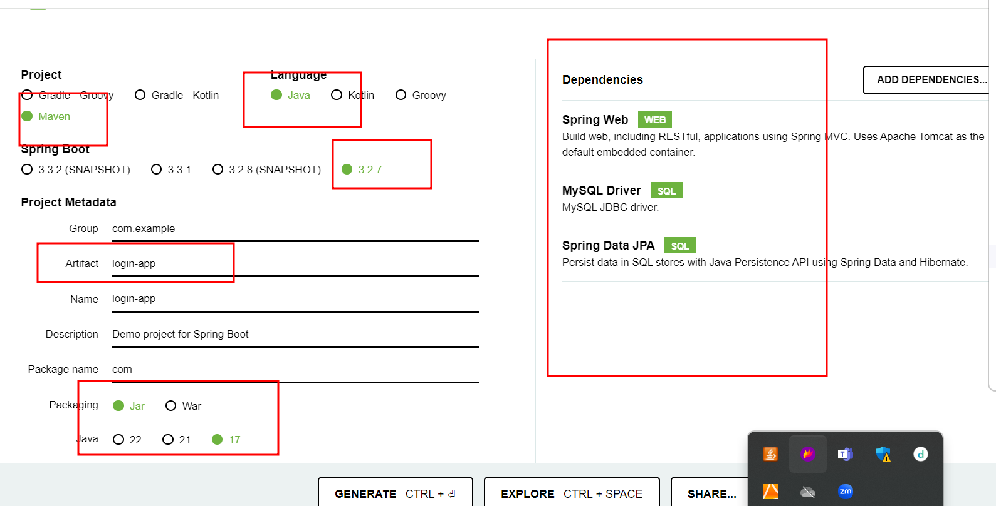

Create the table in db

create table login(emailid varchar(30) primary key,password varchar(30));

Controller or RestController layer depends upon service layer

Controller do the mock for service layer or fake data.

Service layer depends upon dao or repository layer

Service layer do the mock for repository layer

Repository layer depends upon database connectivity

Dao layer can mock dor database

Mockito :it third party library or framework which provide set of annotation which help do the mock or fake data.